EDU2AE/TOP CONTROLLER
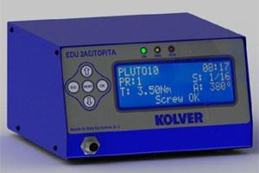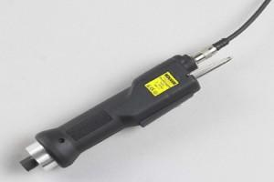
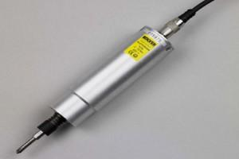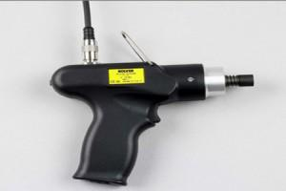
The multiple torque system is designed to expand the functionality of the PLUTO screwdriver by enabling easy access to multiple torque settings with one controller and one Pluto driver only. Models include a double torque output unit and a multiple torque unit EDU2AE/TOP. It features up to 8 programs, each one with different torque values, speed, ramp, screw counting, batch counting, USB port for printer and PC connection, torque chart with real time clock.
• 8 independent programs: with one PLUTO screwdriver you can replace 8 conventional screwdrivers.
• Each program can accept the following settings: Torque, Speed, Type of Joint, Number of Screws to be tightened, Number of Rejects allowed, Minimum screwing time, Maximum screwing time, Ramp time, Auto reverse, Auto switch to the next program with any sequence, Allow or Prevent reverse option: you can find the correct setting for any applications, never miss a screw in your assembly.
• Password protected: no tampering from anybody.
• Statistics menu with summary of work done: at the end of the day you'll know how many cycles have been performed correctly, how many wrongly, total number of screws etc.
• 15 input and 11 output connectors: you can control all functions from PLC.
• Options include USB port, Socket tray or Switch box: maximum flexibility.
• Giant 135 x 40mm blue display: easy to read from any angle.
• Easy programming through user friendly menu.
• Price 3 times lower than any similar product in the market.
The new EDU2AE/TOP control unit features:
• screwdriver model setting
• tightening torque, fastening and unscrewing speed
• type of joint (soft/hard)
• acceleration ramp
• min and max fastening time
• autoreverse
• password protect settings
• prevailing torque function (for an adjustable time)
• clockwise or counterclockwise rotation (right or left screws) with torque control
• torque value in Nm on the display through dedicated calibration menu
• screw count function
• min-max torque interval with OK or NOK signal
• 8 independent programs: with one PLUTO screwdriver you can replace 8 conventional screwdrivers.
• Time and date
• Program selection by barcode
• Program selection by socket tray and/or switchbox
• Also available in TA version with torque/angle combined control functions (see dedicated page)
